**Optimization and Active Stabilization of a Far-Infrared Laser for NSTX-U High Poloidal WavenumberScattering Diagnostics**

**Abstract**

The far-infrared (FIR) laser output beam power and pattern are critical parameters in laser-aided diagnostics, directly influencing the spatial resolution and signal-to-noise ratio of measurements. This work focuses on developing a systematic control method to enhance FIR laser beam quality through optimized mirror alignment and real-time feedback-based precision cavity length tuning. A high-power CO₂ laser, aligned with the waveguide axis using a HeNe reference laser, serves as the pump source. The sensitivity of FIR beam intensity to pump gas pressure and thermal expansion is investigated, revealing that even a 1 μm cavity expansion can significantly degrade output power stability. To address this, a feedback control module has been designed and implemented for active cavity length adjustment, stabilizing the output power at approximately 30 mW. Additionally, maintaining a high formic acid gas pressure (>190 mTorr) within the cavity ensures reliable operation. The optimized FIR laser will be deployed on the NSTX-U high poloidal wavenumber scattering system for studying electron-scale turbulence in tokamak plasmas.

**Section I: Introduction**

Transport is one of the key research topics in fusion plasma physics. In experiments conducted on the NSTX device, electron-scale transport has been observed to exceed neoclassical transport predictions by a significant margin [ref]. This elevated transport can lead to substantial particle and thermal losses, ultimately degrading plasma confinement. Consequently, understanding and controlling electron dynamics is critical for the successful operation of tokamaks. The NSTX-U device, with its distinctive high-beta and low-collisionality conditions, provides an ideal platform for investigating electron-scale turbulence. This study will systematically explore how turbulence characteristics vary with essential parameters such as collisionality, the q-profile, and E×B shear, aiming to identify the mechanisms that govern confinement scaling. An essential diagnostics system in this investigation is the 693 GHz, 8-channel millimeter-wave poloidal scattering system, which will measure electron-scale turbulence across the plasma core to edge (normalized radius from 0.2 to 1) with a poloidal wavenumber range of 7 to ~40 cm−1. This capability enables comprehensive coverage of the predicted electron temperature gradient (ETG) and other electron-scale turbulence spectra.

The system utilizes an optically pumped far-infrared (FIR) laser with formic acid (HCOOH) vapor serving as the gain medium. It is pumped by a 150 W CO₂ laser operating at the 9R20 line (9.27 μm), which drives rotational transitions to generate the 693 GHz FIR signal. The output beam is coupled into a waveguide and directed to the launch optics, where adjustable mirrors allow precise beam steering for various measurement configurations. Maintaining a high-quality Gaussian beam profile is critical for efficient waveguide coupling. This depends sensitively on the precise alignment of FIR cavity components, including perforated copper mirrors, mesh grids, and dielectric wafers. Even minor misalignments (as small as 0.1°) can significantly degrade the output beam quality. Additionally, heat from the CO₂ laser can alter the length of the FIR laser cavity, resulting in a drop in output power. This work addresses these challenges by developing a repeatable alignment methodology and identifying the key factors that govern beam pattern and power optimization in FIR systems.

This paper focuses on optimizing the performance of a 693 GHz far-infrared (FIR) laser through precision optics alignment and cavity length feedback control. The system is driven by a CO₂ pump laser, and its output beam quality is important for high poloidal wavenumber scattering diagnostics. Section 2 reviews the FIR laser setup, while Section 3 presents beam pattern optimization by optics alignment. Section 4 details power stabilization through real-time cavity length feedback control and gas pressure tuning. Finally, Section 5 summarizes the implications for improving FIR laser stability and output efficiency.

**Section II: FIR laser setup and beam quality importance**

1. **FIR laser and CO2 laser system overview**
2. **FIR beam output beam power and pattern distortion affected on scattering system (diagnostics degradation)**
3. **NSTX-U FIR laser requirement**

**Section III: Beam pattern optimization by optics alignment**

1. **Principle of laser optics setup**
2. **Non-ideal beam pattern sample**
3. **Alignment process and beam pattern quality improvement**
4. **Please add a short description about the regular alignment duration requirement**

**Section IV: Beam power stabilization**

1. **Beam power decreasing with nature operation (no feedback control)**
2. **Key parameters (beam power): cavity length, gas pressure**
3. **Beam power performance with feedback control module**
4. **Please add a short description about the regular adjustment duration requirement**

**Section V: Summary**

1. **One sentence about high k scattering laser requirement**
2. **Three sentences about optimized beam power and pattern performance**
3. **Summarize the optics alignment method, cavity length adjustment method, and more.**
4. **Impacts on other laser-aided diagnostics.**

**Section II: FIR laser setup and beam quality importance**

1. **FIR laser and CO2 laser system overview**

The CO2 laser system and FIR laser system are working as a whole laser system to produce coherent laser at 693 GHz. The CO₂ laser serves as the pump source, providing high-power, linearly polarized radiation at a wavelength of 9.27 μm. This radiation is directed into the FIR laser cavity, which contains formic acid gas as the gain medium. The FIR laser operates based on molecular rotational transitions, generating radiation in the submillimeter range (around 432 μm), corresponding to the far-infrared region.

1.1 Overview of CO2 laser

The CO₂ laser schematic shown in Fig. 1 features two independent waveguide cavities, each powered by a dedicated high-voltage supply (-15 kV cathode, 0 V anode) that initiates gas breakdown in the CO₂-N₂-He mixture (6:18:76 ratio). This discharge sustains a 40 mA plasma current that excites CO₂ molecules, producing infrared radiation through quantum cascade transitions. The system employs Brewster windows to enforce P-polarization (100% transmission) while suppressing S-polarization through reflection and absorption. Wavelength selection is achieved via a tunable diffraction grating, which together with the output coupler's ZnSe mirror (60% reflectivity at 10 μm) forms the complete laser cavity. Resonant feedback between these components stimulates continuous laser action, with maximum output occurring when the cavity length satisfies the standing wave condition. Fine adjustment of this critical length (up to 15 μm precision) is accomplished through a piezoelectric crystal stack in the output coupler, controlled by 1500 V DC bias (max.).

Figure . Schematic of the CO₂ laser. The main components include the output coupler, Brewster windows, diffraction grating, and laser cavity waveguide.

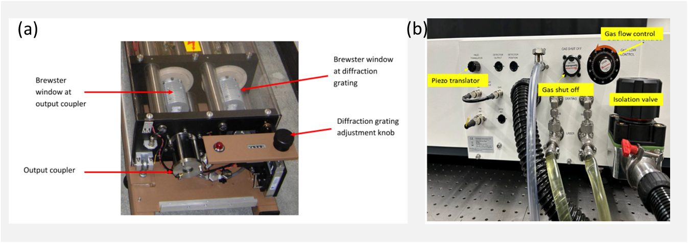

Figure . The CO2 laser system control system

To ensure consistent laser performance and wavelength control, a comprehensive optical and electronic infrastructure is integrated into the system. This includes both the resonant optics and the centralized control interface, which facilitate precise tuning and real-time diagnostics. The control systems of the PL-6 CO₂ laser are shown in Fig. 2 (b). The precise wavelength adjustment is achieved through a mechanical knob with indexed counter readout as shown in Fig. 2 (a). The main control panel (Fig. 2 (b)) integrates all critical subsystems: (1) laser cavity optimization via piezoelectric length adjustment, (2) gas handling with flow control and vacuum systems (Figs. 2 (b)), including real-time pressure monitoring, and (3) thermal management through liquid cooling ports. Power is supplied by dual high-voltage sources (15 kV, 40 mA each), enabling stable operation of the complete laser system.

1.2 Overview of FIRlaser

Figure . Schematic of FIR laser

The schematic of the FIR system is shown in Fig. 3. The system consists of a rear mirror, a dielectric waveguide tube, a front mirror, and a metallic mesh. The rear mirror is a copper mirror coated with gold, featuring a central hole to allow the CO₂ laser to pass through. The front mirror is a dielectric-coated silicon wafer, designed to provide high FIR transmission (98%) and high CO₂ laser reflection (99%). The metallic mesh has a density of 300 lines per inch (lpi), with 20% transmission and 80% reflection for FIR radiation at a 432 μm wavelength.

The front mirror and metallic mesh are mounted on a stage that can be adjusted along the waveguide axis, driven by a stepper motor. The CO₂ laser oscillates between the front and rear mirrors, while the FIR laser oscillates between the metallic mesh and the rear mirror. By adjusting the cavity length between the metallic mesh and the rear mirror, the output power can be optimized to its maximum value. The output window of the FIR laser system is made of HDPE with plano surfaces, as a concave surface would distort the beam profile.

* 1. The feed-in optical system between CO2 pump laser and FIR laser

A schematic diagram of the feed-in system, as shown in Fig. 4, illustrates the optical path and key components, including mirrors, focus lens, beam splitter, and power detectors. Two reflective mirrors are used to adjust the propagation direction of the CO₂ laser into the FIR laser input coupler window. A focusing lens with a 1 m focal length is used to collimate the CO₂ laser. Behind the input coupler window, a copper mirror with a 4 mm radius central hole is installed. The CO₂ laser is focused such that its beam waist is near the mirror aperture, allowing the beam to expand inside the FIR laser. This configuration reduces the amount of CO₂ laser power that can escape back through the input coupler and potentially disrupt the CO₂ laser operation. The beam splitter diverts 5% of the CO₂ laser power to a power monitor for real-time monitoring.

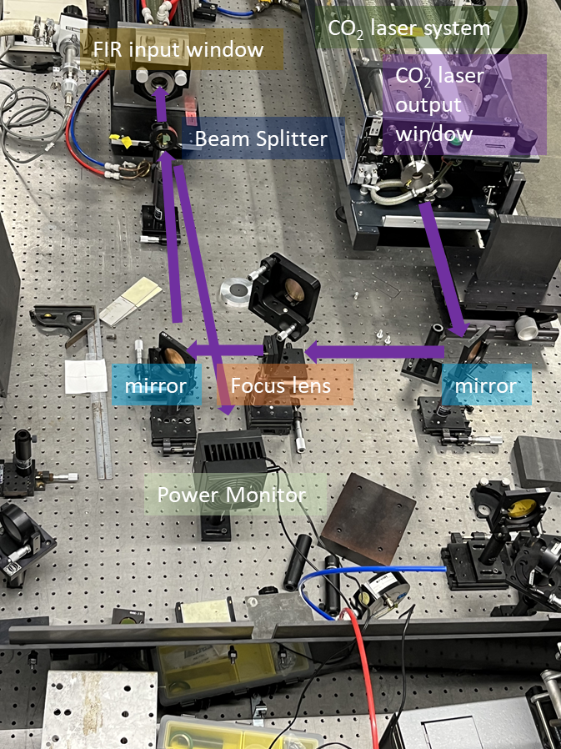

Figure . Optical components between CO2 laser and FIR laser.

1. **FIR beam output beam power and pattern distortion affected on scattering system (diagnostics degradation)**

For the High-k scattering system, the laser system is located far from the NSTX-U device, making a waveguide necessary to minimize transmission losses between the laser and the tokamak. The FIR beam profile is critical for achieving high coupling efficiency with the waveguide, designing the launch optics, and ensuring accurate diagnostic spatial resolution. Only a Gaussian beam profile can provide high coupling efficiency and enable standard optical design techniques, including determining the focal position, conducting beam tracing simulations, and maintaining spatial resolution at scattering region. The FIR beam profile is primarily determined by the internal mirror alignment within the FIR laser system and the condition of the laser’s output window. Under optimal alignment, the resonant mode of the FIR wave in the waveguide should be the fundamental HE₁₁ mode, which approximates a Gaussian beam profile, with an output power of around 30 mW. Any misalignment can excite higher-order modes, leading to significant deviations from the Gaussian profile, and then bad coupling with waveguide, no Gaussian beam profile will also be led to difficult optical design and optical assessment, finally lost the track of beam path, which is not good for diagnostic.

1. **NSTX-U FIR laser requirement**

For NSTX-U, the FIR laser must have sufficient power (wait to check) to achieve a high signal-to-noise ratio, which requires low transmission loss through the waveguide. To minimize refractive effects in plasma, the FIR laser operates at a frequency of 693 GHz. Any other requirements? I will talk with Calvin about this chapter.

**Section III: Beam pattern optimization by optics alignment**

1. **Principle of laser optics setup**

To maximize the FIR laser's output power and ensure an optimal beam profile, the CO₂ laser should be precisely aligned with the FIR laser waveguide axis. Additionally, the mirrors in the FIR laser system must be perpendicular to the waveguide axis to facilitate multiple reflections and support the dominant FIR wave mode, EH11​, which results in a Gaussian beam profile at the output.

1. **Non-ideal beam pattern sample**

Before well alignment of the optical mirrors in the FIR laser system, the FIR beam may exhibit various distorted shapes. One example, shown in Fig. 5, displays a donut-shaped structure, which appears even when the rear and front mirrors are roughly aligned. This beam profile is a typical example of a non-ideal mode, indicating that the laser is operating in a higher-order mode rather than the desired fundamental Gaussian-like mode.

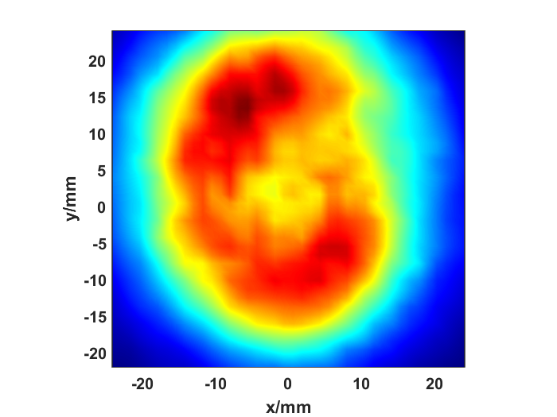

Figure . Donut-shaped beam profile of the FIR laser measured 1 meter from the output window.